Washington State University Vancouver Cleanroom
Standard Operating Procedure

Process: | Copper Etch
Equipment Name: | M.G. Chemicals #416-E ETCHING KIT
Scheduling Name: | Not Applicable | Revision Number: | 0
Model: | #416-E | Revisionist: | Sam Judd
Location: | VECS 221 | Date: | 11/9/2021

M.G. Chemicals cat #416-E Etching Kit contains the following items:  1) A seven-liter polyethylene tank with clear acrylic lid  2) Mounting bracket  3) #416-AP Heavy Duty Air Pump,  4) 3-way adjustable airline manifold  5) Triple line sparging unit  6) #416-AH Air Hose for sparging unit  7) #416-H 200-Watt vertical Heater  8) Tank mounted thermometer  9) #416-G disposable gloves | 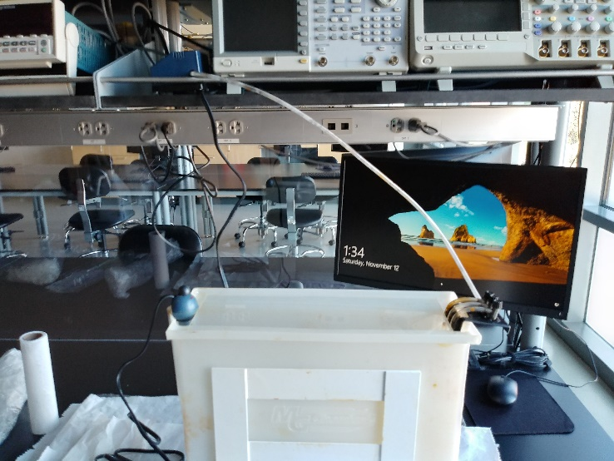 | Voltage: 110 Volts  Air pump &  Vertical Heater

1. SAFETY REQUIREMENTS
- Safety glasses must be worn whenever in the lab, except when wearing protective goggles.
- WARNING: Heating unit must be unplugged to turn off. Do not leave heating unit unattended while it is in use.
- Do not let Etching tank run dry.
- Do not attempt to operate etching kit if tank is less than 3/4 full.
- Avoid skin contact with Etchant or direct breathing of vapor.
Air Pump Installation:
- Air Pump must be placed above the etching tank of etching solution. This will prevent a backflow of etchant into the pump, causing damage to the pump and leakage of etchant.
- Connect the airline to the output on pump. The pump is operational when plugged into wall outlet.

Equipment Setup:
- Mount the heater opposite the spout end of your etching tank. DO NOT PLUG IN HEATER yet.
- Secure the tank within its mounting bracket. With a sparging unit positioned in the tank, ensure the etchant solution is filled to the level indicated on the quartz element of heater.
- Wait 15 minutes for the thermostat to adjust itself to the etchant temperature if colder than room.
- Confirm temperature is set to 32C or the desired temperature for the etch process.
- Plug in the heater.
- Final temperature adjusting may be required. The pilot light should turn on and remain lit until the operating temperature has been reached.
- Allow the heater to operate for one hour. When the desired temperature is reached the pilot light will turn off and the heater will maintain the temperature.

Etch Process:
- Unplug air pump.
- Load circuit boards onto slots in sparging unit.
- Lower sparging unit back into tank and plug air pump back in to continue etchant mixing.
- Check boards for etch progress when adding new board to etch tank.
- Remove boards when copper is removed as desired.
- Students take their board to the cleaning station.
  - Rinse with water.
  - Rinse with IPA/water solution.
  - Rinse with acetone if needed to remove resist.
- Start drilling process if needed for thru-hole boards.

Cleanup:
- Unplug heater and air pump.
- Place heater and sparging unit on paper towels and wipe clean with wet towels.
- Pour the etchant into the etchant container. Mark the number of boards etched and date on container.
- Run water through the sparging unit into tank.
- Rinse tank with water.
- Collect rinse water for disposal by technician.

